 | Problem 1 | Problem 2 | Gridded Response
Monday | Suppose a dog can run 60 feet in 8 seconds. A cat can run 35 feet in 5 seconds. Which animal can run faster? How much faster?  Dog; 0.5 feet per second | Brandon purchased three cheeseburgers for $1.29 each and two milkshakes for $2.75 each. If sales tax is 7.5%, what is the total of Brandon’s purchase? Round to the nearest hundredth.  $10.07 | Problem 2  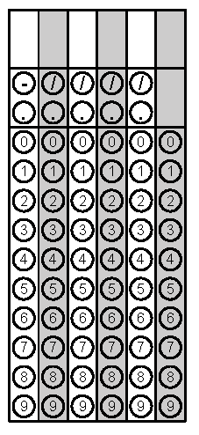
Tuesday | Below is the weight of the five football players from each team. How much higher is the median weight of the Panthers compared to the Steelers?  25 pounds  Panthers Steelers  Cam Newton 245 Ben Roethlisberger 240  Greg Olsen 253 DeAngelo Williams 207  Mike Tolbert 250 Antonio Brown 181  Michael Oher 315 Le’Veon Bell 225  Thomas Davis 235 Ryan Shazier 230 | Solve the inequality.  $$8≤-2x+16$$  $$x≤4$$ | Problem 1
Wednesday | Kabir is laying tile on his rectangular kitchen floor. The dimensions of the floor are $15\frac{1}{2}feet$by $12feet.$ If he is using square tiles with a side length of $\frac{1}{2}foot$, how many tiles will he need to cover the floor?  744 tiles | What is the surface area of this figure?  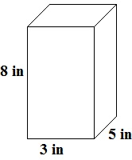  158in² | Problem 2
Thursday | What is the difference between the students’ Mean Absolute Deviation?  Student Test 1 Test 2 Test 3 Test 4  Caleb 70 83 91 98  Isaiah 80 86 83 90  Caleb = 9  Isaiah = 3.25  Difference = 5.75 | Elizabeth’s bathroom is 8 feet by 6 feet. She is laying square tiles with a side length of 3 inches. How many tiles does she need?  768 tiles | Problem 2
Friday | Solve for x.  $$-2=2+\frac{x}{4}$$  x = -16 | Chris has 28 t-shirts. One fourth of the t-shirts are red, three-sevenths of the  t-shirts are blue; the remainder of the t-shirts are gray. How many gray t-shirts does he own?  9 gray t-shirts | Problem 1

