 | Problem 1 | Problem 2 | Gridded Response
Monday | Anthony needs a new suit. He has a 20% off coupon that will be applied before a tax of 7.5% is applied to his total. How much will he end up paying for a $275 suit? Round to the nearest hundredth.  $236.50 | Angles X and Y are supplementary. Angle X measures 2x-9. Angle Y measures 135 degrees.  What is the value of x?  x=27 | Problem 2  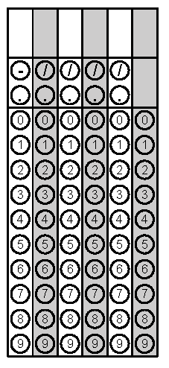
Tuesday | Emily is ordering a pizza online. She will randomly select one crust type, sauce, and topping.  Crust Type Sauce Toppings  Thin Red Sauce Cheese  Hand-Tossed White Sauce Pepperoni  Pan Mushrooms  Spinach  What is the probability she will select Hand Tossed crust, red sauce, and mushrooms?  $$\frac{1}{24}$$ | Based on the table, write an equation to represent the dollars earned, d, for any amount of hours worked, h.  Hours Dollars Earned  2 5  4 10  5 12.5  8 20  $$d=2.5h$$ | Problem 1
Wednesday | Stephanie saved $25 every week for 7 months. Then she spent 65% of the money for a new bike. How much money did she have left?  $245 | David made a scale drawing of his basketball goal. The basketball goal is 15 feet tall. In the drawing the basketball goal is 3 inches. What is the scale of the drawing?  $$\frac{1}{5}in. =1 ft.$$ | Problem 1
Thursday | Diamond is playing Yahtzee with her family. She is using five dice, numbered 1-6. What is the probability she will roll all even numbers?  $$\frac{1}{32}$$ | Simplify the expression  $$-3\left(5x-2y\right)+6(4y+x)$$  $$-9x+30y$$ | Problem 1
Friday | Cameron took his girlfriend out to dinner for her birthday. Dinner was $55.92. Tax on the meal was 7.5% of the price of the meal. They left a tip that was 18% of the meal and tax. What is the total cost of the meal?  $70.93 | Solve for x.  $$-4x-7>1$$  $$x<-2$$ | Problem 1

