 | Problem 1 | Problem 2 | Gridded Response
Monday | The circumference of a circle is 113.04 cm. What is length of the radius rounded to the nearest centimeter?  18 centimeters | The Jones family is adding a rectangular swimming pool to their backyard. The blueprint of the pool measures 5 in. x 8 in. The scale of the blueprint is 1in. = 2.5 feet. What are the actual dimensions of the pool?  12.5 feet x 20 feet | Problem 1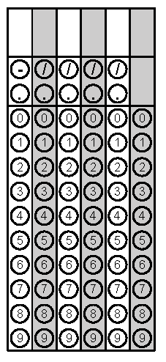
Tuesday | Jonathan built a scale model of his house. He built the model 5 inches tall to represent the actual height of 20 feet. Write an equation that represents the relationship between the actual height, a, in feet, and the height of the model, m, inches?  $$m=\frac{1}{4}a$$ | A sweater at Target costs $28. After tax the sweater is $30.24. What is the sales tax rate?  8% | Problem 2
Wednesday | There are three colors of marbles in the bag: red, green, and yellow. If the probability of getting a red was $\frac{2}{5}$ and the probability of getting a green was $\frac{1}{3}$, what is the probability (in fraction form) of getting yellow?  $$\frac{4}{15}$$ | Simplify  $$-\frac{1}{3}\left(12x-9\right)-(6x-4)$$  $$-10x+7$$ | Problem 1
Thursday | Betty mixed $1\frac{1}{2}$ gallons of yellow paint with $2\frac{1}{2}$ gallons of blue paint to make green paint for her treehouse. She ran out of green and needs to make more. If she uses 4 gallons of blue paint, to keep the same ratio, how much yellow paint should Betty use?  $2\frac{2}{5}$gallons of yellow | Caleb has a job at the grocery store. He earns $6.25 an hour for bagging groceries and $4.50 an hour for returning carts. Last night, he bagged groceries for 4 hours and returned carts for 2.5 hours. How much money did Jeff make last night?  $36.25 | Problem 2
Friday | Solve for x.  $$\frac{x+6}{-2}=-7$$  x = 8 | If ∠abd is 50°, what is the measure of ∠cbd?  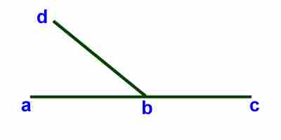  130 degrees | Problem 1

