 | Problem 1 | Problem 2 | Gridded Response
Monday | Aarav spent $29 to take his girlfriend to the movies. He spent 30% on snacks and the remainder was spent on the two tickets. How much was each ticket? | The chart below shows how long Alexis spent on homework the last two weeks, in minutes. What is the approximate difference in each week’s average?  Mon Tue Wed Th  Week 1 26 34 28 32  Week 2 25 32 26 40 | Problem 1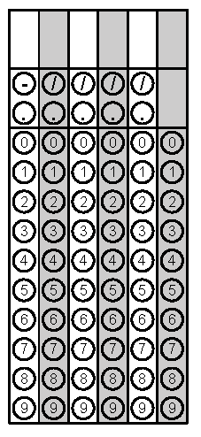
Tuesday | On a set of blueprints for a new home, the contractor has established a scale that states $\frac{1}{2}$ inch = 8 feet. What is the actual width of the living room whose distance is $1\frac{1}{4}$inch on the blueprints? | Simplify. Write your answer as a decimal.  $$-4[2^{3}+{\left(\frac{3}{4}\right)}^{2}]$$ | Problem 2
Wednesday | Two stores have headphones on sale. Store A has the headphones on sale for 40% off the original price of $159.99. Store B has the headphones on sale for 25% off the original price of $130.50  What is the difference in the sale prices? | Julie bought 3.5 pounds of apples to make a pie. The total was $3.43. How much does one pound of apples cost? | Problem 2
Thursday | Camilla has three pieces of ribbon that measure 6 feet, 3 feet, and 10 feet. Without cutting the ribbon, can Jennifer make a triangle out of the pieces of ribbon? | What is the volume of this prism?  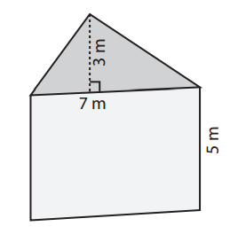 | Problem 2
Friday | Simplify  $$-7\left(x+6\right)+3x+14$$ | Solve for x.  $$-15=-4m+5$$ | Problem 2

