 | Problem 1 | Problem 2 | Gridded Response
Monday | Santiago is making a model airplane. He is using the scale $\frac{1}{4}in. =2 feet.$ If the actual length of the plane’s wing is 58 feet; how long should the wing be in his model? | Alyssa is making cakes. In 6 cakes she uses $10\frac{1}{2}cups$ of sugar. How much sugar is in one cake? | Problem 2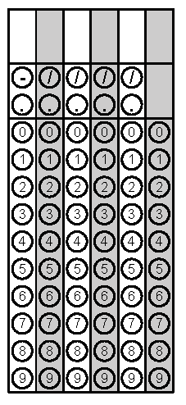
Tuesday | Solve for x.  $$-9x-13=-103$$ | Simplify  $$-\left(6a-2b\right)-8\left(b+a\right)$$ | Problem 1
Wednesday | Arjun earned the following amounts the last three weeks. How much does Arjun earn per hour?  Hours Worked (h) Amount Earned (E)  14 $192.50  18 $247.50  33 $453.75 | Diego is painting lines on a basketball court. What is the area inside the lines?  Round your answer to the nearest hundredth.  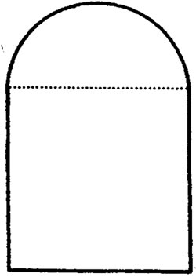  15 cm  15 cm | Problem 1
Thursday | What is the area of the non-shaded area to the nearest hundredth?  22 in  22 in | SuperSaver grocery store advertises a special on 2-liter bottles of soft drinks. The first bottle purchased is $1.25 and each bottle after that is $0.75. Write an expression that can be used to find the total cost. Find the total cost if you purchase 8 bottles. | Problem 2
Friday | A cylinder is cut perpendicular to the base. What is the shape of the cross section? | When Valerie planted a tree in her yard it was 12 inches tall. It grew at a rate of 1.5 inches per month. The tree is now 37.5 inches tall.  How many months has it been since Valerie planted the tree? | Problem 2

