 | Problem 1 | Problem 2 | Gridded Response
Monday | Simplify  $$2\sqrt{49}-\sqrt{146-25}+9$$  12 | Joseph is measuring the length of his house. He finds it is $25.\overline{4 }$ feet long. Write this value as an improper fraction.  $$\frac{229}{9} feet$$ | Problem 2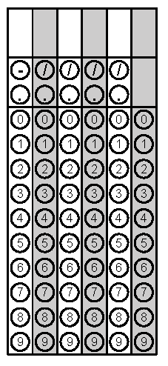
Tuesday | Circle the rational numbers.  $$-\frac{3}{11}$$  $$\sqrt{36}$$  $$\frac{-2π}{5}$$  $$3\sqrt{200-4}$$ | Simplify  $$\frac{4^{-1}}{4^{-4}}$$  64 | Problem 2
Wednesday | Benjamin is moving to college. He has six cubic crates to pack his things. Each crate has a side length of 3 feet. What’s the total volume of all seven crates?  162 cubic feet | One side of a pentagon measures $\sqrt{40} inches.$ What is the measure of this side as a decimal to the nearest hundredth?  6.32 feet | Problem 2
Thursday | Simplify  ${(a^{-4}bc^{3})}^{0}∙a^{3}b$  $$a^{3}b$$ | Victoria is helping her teacher decorate a square bulletin board. The area of the board is 144 square inches. How many inches of border does Victoria need to go around the bulletin board?  48 inches | Problem 2
Friday | Simplify  $$\frac{2}{5}∙0.\overline{1}$$  $$\frac{2}{45}$$ | Circle the natural numbers.  $$\frac{18}{3}$$  $$4\sqrt{9}$$  $$-6$$  $$0$$ | Problem 1

