 | Problem 1 | Problem 2 | Gridded Response
Monday | Hailey spends $460 for monthly bills. Of this amount she spends $\frac{1}{8 }$ on her cell phone bill and 15% on her car payment. The remainder pays her utilities. How much money does she spend on utilities?  $333.50 | Solve: $3-4\frac{2}{5}$  $$-1\frac{2}{5}=-\frac{7}{5}$$ | Problem 2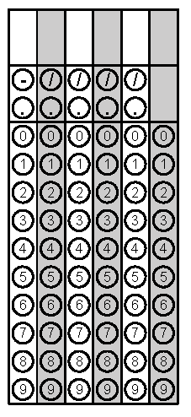
Tuesday | One lap around a track is equal to one-third of a mile. Mandy, the horse, ran a distance of 12 laps in 2 minutes and 30 seconds. What was the horse’s average speed in miles per minute?  1.6 miles per minute | Solve and graph.  $$-6x≥18$$  $$x≤-3$$ | Problem 1
Wednesday | Arjun wrote the numbers 1, 2, 3, 4, 5, 6, 7, and 8 and put them in a hat. What is the probability he will draw a number greater than 6?  $$\frac{1}{4}$$ | Find the value of x.  x = 65  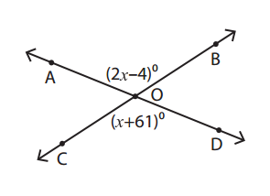 | Problem 1
Thursday | A baker made two cakes of the same size.  - At the end of the day,  there was $\frac{3}{4}$ of a carrot  cake left.  - There was $\frac{4}{5}$ of a red velvet cake left.  - The baker divided the remaining carrot cake into 3 equal pieces and the remaining red velvet cake into 4 equal pieces.  Which cake flavor had larger pieces and by how much?  Carrot Cake $\frac{1}{20}$ of a cake more | Simplify  2 (1-4)² + 42(15-9)  25 | Problem 2
Friday | A teacher is collecting data on what TV show is the students’ favorite. What would be a good method of surveying customers?  Answers will vary. Students should have some type of random survey with a large enough sample size. | Find the area of the shaded region. The circle has a radius of 3 inches and the triangle has a base of 6 inches. Round to the nearest tenth.  19.26 in² | Problem 2

