 | Problem 1 | Problem 2 | Gridded Response
Monday | Convert to standard notation. 3.85 x 10⁶ | Carl ate $\frac{3}{7}$ of the pizza. Jenny ate $\frac{1}{4}$of the pizza. How much did they eat altogether? | Problem 2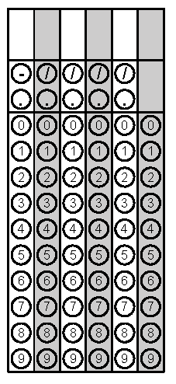
Tuesday | What would be the best measurement for the amount of water a dog drinks in a day:  Gallons or Fluid Ounces? | Find the sum of the integers between $-\sqrt{15 }$ and $\sqrt{50}.$ | Problem 2
Wednesday | Estimate $-\sqrt{10}$to the nearest tenth. | Simplify  (3x²y)⁴ | Problem 1
Thursday | Circle the whole numbers.  $$-\sqrt{49}$$  $$0$$  $$-5$$  $$\frac{2π}{π}$$ | Simplify.  $\sqrt{126-45}$ − $\sqrt{4}$ | Problem 2
Friday | Evaluate  $$(2^{3})(2^{-6})$$ | Convert to a fraction.  $$2.\overline{45}$$ | Problem 1

