 | Problem 1 | Problem 2 | Gridded Response
Monday | Evaluate  (2³)⁵  (2⁴)(2¹)  1024 | Which point best represents  $\sqrt{75}$?  Point C | Problem 1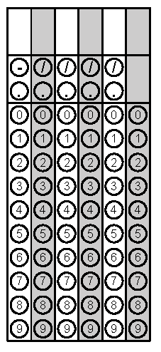
Tuesday | Order the values below from greatest to least.  $\sqrt{10}$  3  $\frac{14}{5}$  2.6  $$2.6, \frac{14}{5},3 and \sqrt{10}$$ | Jayla is trying to determine how much icing she will need to put on the border of a birthday cake she is making. What is the perimeter of her square cake pan with an area of 144 square inches?  48 inches | Problem 2
Wednesday | Evaluate  $$\frac{2^{-3}}{5^{2}}$$  $$\frac{1}{200}$$ | Order from least to greatest.  4.6 x 10⁵  5.2 x 10³  4.9 x 10²  5.5 x 10³  4.9 x 10²  5.2 x 10³  5.5 x 10³  4.6 x 10⁵ | Problem 1
Thursday | A 5-pound package of ground beef is $10.10. A ½-pound package is $1.05. What is the difference in the cost per pound between the larger and smaller packages of beef?  $0.08 per pound | Convert the decimal to a fraction.  $0.\overline{18}$  $$\frac{2}{11}$$ | Problem 2
Friday | A triangle has one side that measures $\sqrt{88} inches.$ Estimate this value to the nearest hundredth.  9.38 | Classify as rational or irrational.  $\frac{4}{7}$ Rational  6$π$ Irrational  $\sqrt{15}$ Irrational  0.1$\overline{5}$ Rational | Problem 1

