 | Problem 1 | Problem 2 | Gridded Response
Monday | Express $1.9\overline{3}$ as fraction. | Identify the following as rational or irrational.  $-\frac{21}{9}$  $\frac{π}{2}$  $21.875$ | Problem 1  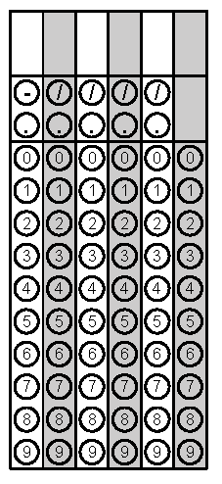
Tuesday | What is the value of  $\frac{3}{5}∙0.\overline{15}$? | Simplify $\frac{a^{-2}c^{5}}{{b^{-3}c}^{3}}$ | Problem 1
Wednesday | List the following numbers in order from least to greatest.  $-\sqrt{28}$ $-5.15$ $-\frac{16.5}{3}$ | Jada is building a square vegetable garden. She is going to put cedar timbers along the border of her garden. Each timber is 5 feet. If Jada wants the area of the garden to be 100 square feet, how many timbers should Jada buy? | Problem 2
Thursday | The distance from the Sun to Venus is 6.7 x 10⁷ miles. There are 25 million miles between Venus and Earth. How far is Earth from the Sun? | Approximate $\sqrt{75}$to the nearest hundredth. | Problem 2
Friday | Convert $\frac{5}{8}$ to a decimal. | Circle the irrational numbers  $$\sqrt{18}$$  $$0.\overline{62}$$  $$4^{-3}$$  $$0.167214…$$  $$3\sqrt{36}$$ | Problem 1

