 | Problem 1 | Problem 2 | Gridded Response
Monday | What is the value of the expression?  $$\frac{6.5 × {10}^{-7}}{0.002}$$  3.25 x 10⁻⁴ | What is the sum of the integers between $\sqrt{10}$ and $\sqrt{60}?$  22 | Problem 2  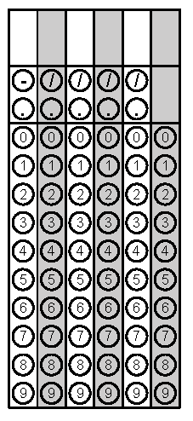
Tuesday | On a number line, Point A represents the smallest integer value greater than $\sqrt{70.}$ Point B represents the largest integer that is less than $-\sqrt{20.}$ What is the distance between point A and point B?  14 units | Simplify:  $$\frac{{(2a^{4}b^{3})}^{3}}{4a^{2}∙a^{3}}$$  $$2a^{7}b^{9}$$ | Problem 1
Wednesday | The diameter of one strand of human hair is about  1.5 x 10⁻² inches. What is the diameter of a pony tail made of 100,000 strands of hair?  1.5 x 10³ inches | The area of a game board is 49 square units. What is the perimeter of the game board?  28 units | Problem 2
Thursday | Evaluate  $$4\sqrt{4}+\sqrt{144}-\sqrt{55+45}$$  10 | The recipe for a dozen biscuits is below. If Lynnae needs to bake 35 biscuits, how much flour should she use? Write as an improper fraction.  $1\frac{1}{2}$ c. flour  $\frac{1}{4}$ c. butter  $1\frac{1}{3}$ c. buttermilk  $4\frac{3}{8}=\frac{35}{8}$ cup | Problem 2
Friday | Evaluate. Leave as an improper fraction.  $$\frac{{(2^{4})}^{2}∙3^{3}}{3^{6}}$$  $$\frac{256}{27}$$ | How many times larger is  1.2 x 10⁸ compared to  3 x 10⁴?  4 x 10³ times larger | Problem 1

