 | Problem 1 | Problem 2 | Gridded Response
Monday | The largest elephant on record weighed 2.4 x 10⁴ pounds. When elephants are born they weight about 110 pounds. About how many times larger is the largest elephant compared to when it was born? Round answer to the nearest whole number. | Find the product of the integers between $-\sqrt{2 }$and$-\sqrt{20}$. | Problem 2  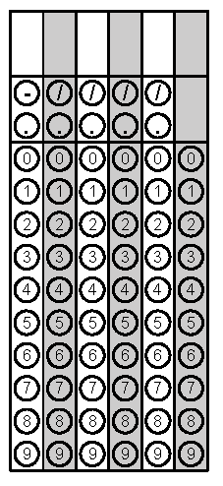
Tuesday | A square has an area of $\frac{25}{64} {inches}^{2}.$In inches, what is the length of each side of the square? | Order the following values from least to greatest.  $$\sqrt{17}$$  $$2^{2}$$  $$π$$  $$\frac{7}{2}$$ | Problem 1
Wednesday | Using the equation  $$\frac{4^{x}}{4^{y}}=\frac{1}{4^{5}}$$  find the value of x if y = 9. | Robert is shopping for cubic toy chests. One chest has a volume of 343 cubic feet. Another chest has a volume of 64 cubic feet. What is the difference in the side lengths of the two chests? | Problem 1
Thursday | Circle the irrational values.  $$\sqrt{\frac{1}{8}}$$  $$\sqrt{225}$$  $$\sqrt[3]{18}$$  $$0.2\overline{8}$$ | Find the value of  $$0.2\overline{7 }∙4\frac{2}{5}$$ | Problem 2
Friday | Find the value of x.  $$x^{3}=\frac{8}{125}$$ | A piece of construction paper has a thickness of  4.3 x 10⁻³ inches. A piece of cardstock has thickness of 5.2 x 10⁻³ inches. How tall is a stack of 15 sheets of construction paper and 20 sheets of cardstock? Write your answer in scientific notation. | Problem 1

