 | Problem 1 | Problem 2 | Gridded Response
Monday | Simplify  $$\frac{{10}^{-5}∙{10}^{-8}}{{10}^{-11}}$$ | Santana missed 2 out of 11 questions on her science test. What percentage did she answer correctly on the test? Write your answer as a repeating decimal. | Problem 1  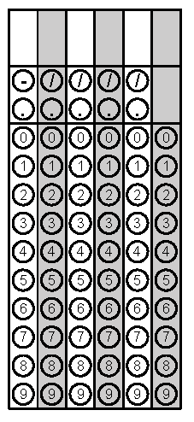
Tuesday | In 2015, the approximate population of North Carolina was 1 x 10⁷ people. Also, there were about 2.3 x 10⁶ people under the age of 18. About what percent of the people in NC in 2015 were under the age of 18? | Malik is painting a square mural on the wall. The area of the mural is 75 square inches. Rounding to the nearest hundredth inches, about how long is each side of the mural? | Problem 2
Wednesday | Which point best represents the $\sqrt{10?}$ | Ishaan grew $1.\overline{15}$inches in June and $0.\overline{6}$ inches in July. How much more did Ishaan grow in June than July? | Problem 2
Thursday | The perimeter of a stop sign is 120 inches. Each side of the stop sign is 3x - 6 inches. Find the value of x. | Simplify  $${\left(4a^{2}b^{-5}\right)}^{0}∙5a^{2}∙{\left(4a^{6}\right)}^{2}$$ | Problem 1
Friday | Lucia has two rectangular playpens to keep her new dogs. The first rectangle has a width of 10 feet and a length of x - 6 feet. The second rectangle has a width of 4 feet and a length of  x + 5 feet. What is the sum of the two perimeters? | The product of eight and a number decreased by four is the same as eight plus five times the same number. What is the number? | Problem 2

