 | Problem 1 | Problem 2 | Gridded Response
Monday | Simplify  $$\frac{{10}^{-5}∙{10}^{-8}}{{10}^{-11}}$$  $$\frac{1}{100}$$ | Santana missed 2 out of 11 questions on her science test. What percentage did she answer correctly on the test? Write your answer as a repeating decimal.  $$81.\overline{81}\%$$ | Problem 1  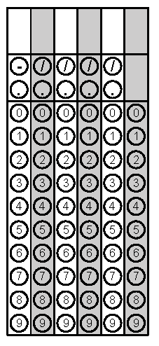
Tuesday | In 2015, the approximate population of North Carolina was 1 x 10⁷ people. Also, there were about 2.3 x 10⁶ people under the age of 18. About what percent of the people in NC in 2015 were under the age of 18?  23% | Malik is painting a square mural on the wall. The area of the mural is 75 square inches. Rounding to the nearest hundredth inches, about how long is each side of the mural?  8.66 inches | Problem 2
Wednesday | Which point best represents the $\sqrt{10?}$  Point B | Ishaan grew $1.\overline{15}$inches in June and $0.\overline{6}$ inches in July. How much more did Ishaan grow in June than July?  $$\frac{16}{33}inches$$ | Problem 2
Thursday | The perimeter of a stop sign is 120 inches. Each side of the stop sign is 3x - 6 inches. Find the value of x.  x = 7 | Simplify  $${\left(4a^{2}b^{-5}\right)}^{0}∙5a^{2}∙{\left(4a^{6}\right)}^{2}$$  $$80a^{14}$$ | Problem 1
Friday | Lucia has two rectangular playpens to keep her new dogs. The first rectangle has a width of 10 feet and a length of x - 6 feet. The second rectangle has a width of 4 feet and a length of  x + 5 feet. What is the sum of the two perimeters?  4x + 26 | The product of eight and a number decreased by four is the same as eight plus five times the same number. What is the number?  x = 4 | Problem 2

