 | Problem 1 | Problem 2 | Gridded Response
Monday | What is the value of the expression?  $$\frac{3^{-3}}{3^{-7}}∙3^{-1}$$ | The length of one side of a triangle is $4\sqrt{6.}$ Is the length rational or irrational? Explain your answer. | Problem 1  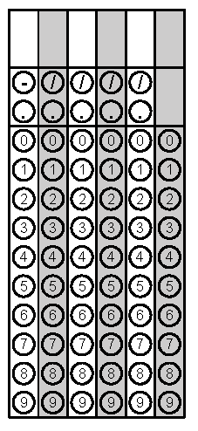
Tuesday | Find the product of  0.04 x 90,000,000 x 0.02.  Write your answer in scientific notation. | A rectangle has a perimeter of 44 inches. The length of the rectangle is four more than two times the width. What is the area of the rectangle? | Problem 2
Wednesday | A gym membership charges an initial fee of $105 plus a $25 fee every month. Another gym only charges $60 every month. After how many months will the total cost for both gyms be the same? | The number of fish in Lake Jordan is about 3.4 × 10⁷. The number of fish in Falls Lake is about 8 × 10⁴. How many fish are in the lakes altogether? | Problem 1
Thursday | Simplify  $$0.\overline{21}∙\frac{4}{7}$$ | Find the value of x. Write your answer in simplest form.  $$x^{2}=\frac{36}{196}$$ | Problem 1
Friday | Lines x and y are parallel. The measure of angle 1 is 4x - 8 and the measure of angle 8 is 2x + 16. Find the value of x. | Mia is planting flowers in her yard. She buys 18 pansies and 15 mums, which cost a total of $120. If mums cost two times as much as pansies, how much does each type of flower cost? | Problem 1

