 | Problem 1 | Problem 2 | Gridded Response
Monday | Solve for x.  $$\frac{-2x-8}{4}=-7$$  x = 10 | Circle the integers. If it is not an integer, explain why.  $$-\sqrt{49}$$  $\frac{5}{π}$ Irrational  $$\sqrt[3]{-125}$$  $8.\overline{152}$ Decimal | Problem 1  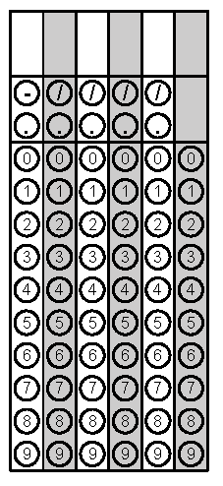
Tuesday | On a number line, Point X represents $-3\sqrt{25+24.}$ Point Y represents  $\sqrt[3]{64}+2^{2}.$What is the distance between the two points?  29 units | In the figure below, lines a and b are parallel. The measure of angle 5 is 75º and the measure of angle 8 is 45º. Find the measure of angles 3.  m<3 = 60 degrees  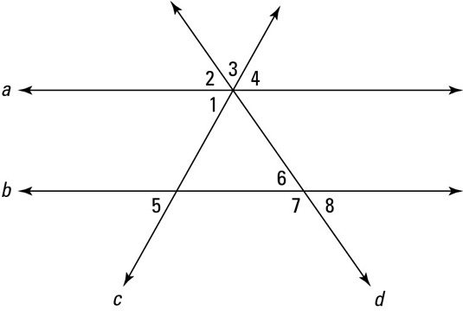 | Problem 1
Wednesday | Michael wants to join a gym. Gym A charges a $40.00 membership fee and $15 per month. Gym B does not charge a membership fee, but charges $25.00 per month. If Michael plans to join the gym for 6 months, which gym should he choose?  Gym A | Solve for x.  $$\frac{3}{4}\left(12x-20\right)=5x+17$$  $$x= 8$$ | Problem 2
Thursday | Don works as a plumber. He charges $75.00 flat fee for a service call and $22.50 for each hour of labor. Don was paid $187.50 for his last job. How many hours did Don work on his last job?  5 hours | Simplify  $$\frac{4a{(2a^{-4}b^{3})}^{2}}{{(6a^{2}b)}^{3}}$$  $$\frac{2b^{3}}{{27a}^{14}}$$ | Problem 1
Friday | Juan bought 27 bags of dirt to completely fill a cube-shaped flower garden. Each bag fills one cubic foot in the flower garden. What is the length, in feet, of one of the sides of the flower garden?  x = 3 feet | Find the measures of each angle.  30x - 5  A  C  9x - 1  B  6x + 6  Measure of Angle A = 115º  Measure of Angle B = 30 º  Measure of Angle C = 35 º | Problem 1

