 | Problem 1 | Problem 2 | Gridded Response
Monday | Solve for x.  $$1000x^{3}=512$$  x = $\frac{8}{10}$ = $\frac{4}{5}$ | Write an expression, using multiplication, that is equal to $4x^{12}.$  Answers will vary.  Example: ${(2x^{6})}^{2}$ | Problem 1  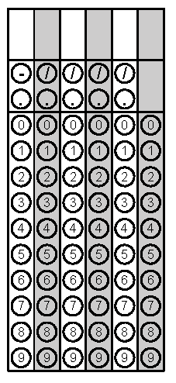
Tuesday | Solve for y.  $$2x-6y= -54$$  $$y=\frac{1}{3}x+9$$ | Simplify  $(4)\sqrt{\frac{64}{25}}-9$  $$-2\frac{3}{5}=-\frac{13}{5}$$ | Problem 2
Wednesday | Triangle ABC is similar to triangle DEF.  - Triangle ABC is a right triangle.  - m<A = 3x - 6º  - m<B = 4x + 12º  - m<C = 90º  What is the angle measure of the smallest angle of Triangle DEF?  30 degrees | Solve for x.  $$4x-4+5x=-x+2(5x-2)$$  Identity or Infinitely Many Solutions | Problem 1
Thursday | What are the two square roots of…  $$\sqrt{-29+110}$$  9 and -9 | Zoe received an iApps gift card for her birthday. All the apps she wants to purchase are the same price. She can buy five apps and have four dollars left over or she can buy three apps and have eight dollars remaining. How much is each app?  2 dollars | Problem 2  1
Friday | Approximate $-\sqrt{65}$ to the nearest hundredth.  -8.06 | Solve for a.  $$a^{2}+b^{2}=c^{2}$$  $$a= \sqrt{c^{2}-b^{2}}$$ | Problem 1

