 | Problem 1 | Problem 2 | Gridded Response
Monday | In Yahtzee, you play with five dice. All the dice are the same size. If the total volume of all five dice is 135 cubic centimeters, how long is each side of a single die?  3 cm | The angles of a triangle measure 67º, 42º, and 71º. What is the measure of the smallest exterior angle of the triangle?  109 degrees | Problem 1  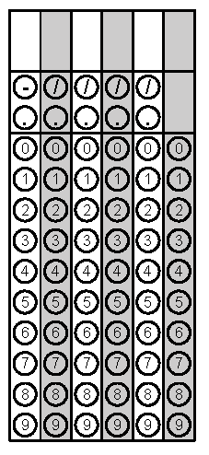
Tuesday | Place the following numbers in order from greatest to least. Classify each number as rational or irrational.  $\sqrt{48}$ Irrational  $6.8$ Rational  $\frac{44}{6}$ Rational  $7.3$ Rational  $\frac{44}{6}, 7.3, \sqrt{48}, 6.8$ | Find the area of the triangle.  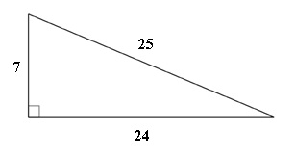  84 units squared | Problem 2
Wednesday | What is the value of  $$\frac{2^{6}∙2^{-5}∙3^{1}}{2^{5}∙3^{-9}∙3^{6}}$$  $$\frac{81}{16}$$ | Good Times Videos charges nonmembers $4 to rent each video. If you get a store membership it costs $20 and members only pay $1.50 to rent each video. For what number of videos is the cost the same? Write and solve an equation.  8 videos | Problem 1
Thursday | Billy ate $\frac{3}{7}$ of a pizza. Gabriel ate $0.\overline{4}$ of a pizza. Who ate more pizza? How much more did they eat?  - Gabriel  - $\frac{1}{63}more$ | Molly is moving to college and has many items she wants to take with her. She has decided to pack some of her items in a crate the shape of a cube. If one side of the crate is 3.6 feet in length, how much of Molly’s stuff will the crate hold (in cubic feet)?  46.656 cubic feet | Problem 2
Friday | Solve for h.  $$A=\frac{bh}{2}$$  $$h=\frac{2a}{b}$$ | Line x and line y are parallel. They are cut by transversal s and transversal t. Find the value of m.  45⁰  x  m  125⁰  y  t  s  100 degrees | Problem 2

