 | Problem 1 | Problem 2 | Gridded Response
Monday | Solve for x.  $$-3\left(2x-3\right)+4x=-4x-7+2x$$ | When building a house, builders often use diagonal braces to stabilize parts of the walls. If Macy is building a house and has a wall that is 9 feet by 12 feet, how long is the diagonal brace? | Problem 2  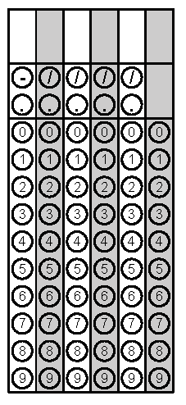
Tuesday | Simplify  $$0.\overline{3}∙4\frac{2}{3}$$ | Draw two parallel lines cut by a transversal. Label two angles that represent alternate exterior angles. | Problem 1
Wednesday | Jocorri is saving to buy his mom a $52 necklace for Mother’s Day. Jocorri has 35 dollars saved and decides to save 1.00 each day from his lunch money. How many days will Jocorri have to save before he can buy the necklace? | If the area of a square is 75 square inches, estimate the length of each side to the nearest tenths place. | Problem 1
Thursday | An Isosceles Triangle has two congruent angles. If one of the congruent angles is 54°, find the measures of the other two angles in the triangle. | Simplify  $$-9\sqrt{\frac{64}{81}}+ \sqrt{54-38}$$ | Problem 2
Friday | Jumbo Cream makes a jumbo ice cream cone. If the cone has a height of 12 inches and a diameter of 7 inches, how much ice cream will fit in the cone? Round to the nearest hundredth. | Solve for y.  $$6x-2y=-28$$ | Problem 1

