 | Problem 1 | Problem 2 | Gridded Response
Monday | The two triangles below are similar. Find the value of x.  4 in  x  5 in  3 in | A triangle has a side length that is the same as the length of a square with an area of 36 square units. Another side of the triangle is 8 units. How long must the third side be for the triangle to be a right triangle? | Problem 1  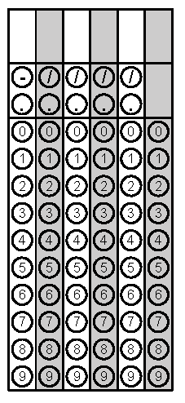
Tuesday | Solve for x.  $$8x= \frac{8x-4}{3}$$ | A triangle has angles measures of 35$°$, 65$°$, and 2x$°.$Find the measure of the third angle. | Problem 1
Wednesday | Chaz drives 24 miles north and 7 miles east. If instead he had taken a direct route how far would he have driven? | Jian finds the volume of a hemisphere by taking half of a sphere. Is he correct? If so, find the volume of a hemisphere with a radius of 2 centimeters. Round to the nearest hundredth. | Problem 1
Thursday | Convert $3.\overline{27 }$to a fraction. | Find the area of a triangle with a hypotenuse of 19 and a height of 8. Round you answer to the nearest tenth. | Problem 1
Friday | On a coordinate plane point A is at (1, 4) and point B is at (-3, 1). Find the distance between the two points. | Peter is using a side of a cube shaped packing box for an art assignment. He knows the volume of the box is 15 cubic feet. How much area does he have to work with if he is using the side of the box for his assignment? | Problem 1

