 | Problem 1 | Problem 2 | Gridded Response
Monday | Determine if a triangle with side lengths 7.5 units, 10 units, and 12.5 units is a right triangle. | Find the value of x?  45  67 x | Problem 2  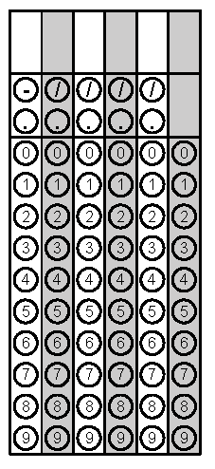
Tuesday | Solve for x.  $$-3\left(x+6\right)-5x= -9x-18+x$$ | Gracie would like a water bottle that holds at least 450 cubic inches of water. She finds a cylindrical water bottle with a radius of 5 inches and a height of 6 inches. Will this hold enough water? | Problem 2 (How much does bottle hold)
Wednesday | Angle 1 and Angle 2 are a linear pair. If Angle 1 had has a measure of 5x + 1 and Angle 2 has a measure of x – 1, find the value of x. | Plot $-\sqrt{3}$ on the number line below.  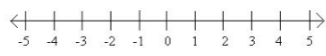 | Problem 1
Thursday | Anisha is cleaning the outside of her bedroom window. She leans her 25 foot ladder against her house. The base of the ladder is 7 feet from the house. How high up is Anisha’s bedroom window? | Order the numbers below from least to greatest.  $9.1$, $4π$, $\sqrt{144}$, $\frac{38}{4}$ | Problem 1
Friday | A small box of rice has 5.6 x 10⁴ pieces of rice. If the larger box has 20 times more pieces of rice, how many pieces does it hold? Write your answer in scientific notation. | Movie time sells their popcorn in cone shaped containers. How much popcorn will their small container hold if it has a height of 10.4 inches and a radius of 4 inches? Round to the nearest whole number. | Problem 2

