 | Problem 1 | Problem 2 | Gridded Response
Monday | The surface area of the Atlantic Ocean is approximately 41,100,000 square miles. Write this value in scientific notation. | Twelve less than a number times three is the same as the product of five and the number increased by six. Find the number. | Problem 2  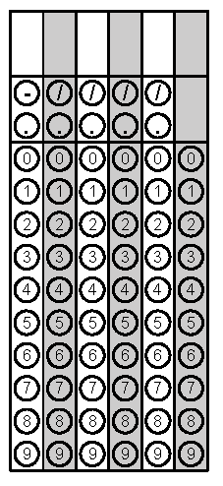
Tuesday | Find the volume of a cylinder with a height of 16 inches and a diameter of 8 inches. Leave your answer in terms of pi. | Find the area of a triangle with a height of 12cm and a hypotenuse of 13cm. | Problem 2
Wednesday | Evaluate  $$-3\sqrt{169-25}+\sqrt[3]{125}-\sqrt{64}$$ | Convert $0.\overline{45}$ to a simplified fraction. | Problem 1
Thursday | Find the volume of a sphere with a diameter of 36in to the nearest tenth of an inch. | The measure of one angle of a triangle is three times the measure of the second angle. The measure of the third angle is 6 less than the sum of the other two. Find the measure of the largest angle. | Problem 1
Friday | What is the measure of the smallest exterior angle of a right triangle if one of the other angles is 30$°$? (Hint: Draw the right triangle and label the information given.) | The points (5, -3) and  (-3, -3) are adjacent vertices of a rectangle. If two of the sides of this rectangle have a length six units, what is the diagonal length of the rectangle? Round to the nearest tenth. | Problem 1

