 | Problem 1 | Problem 2 | Gridded Response
Monday | The surface area of the Atlantic Ocean is approximately 41,100,000 square miles. Write this value in scientific notation.  41.1 x 10⁷ square miles | Twelve less than a number times three is the same as the product of five and the number increased by six. Find the number.  x = -21 | Problem 2  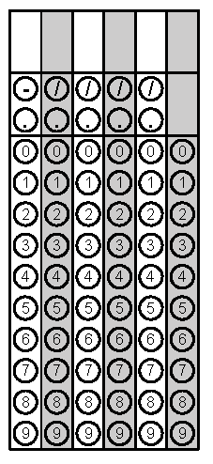
Tuesday | Find the volume of a cylinder with a height of 16 inches and a diameter of 18 inches. Leave your answer in terms of pi.  1296$π$ cubic inches | Find the area of a triangle with a height of 12cm and a hypotenuse of 13cm.  30 cubic centimeters | Problem 2
Wednesday | Evaluate  $$-3\sqrt{169-25}+\sqrt[3]{125}-\sqrt{64}$$  -39 | Convert $0.\overline{45}$ to a simplified fraction.  5/11 | Problem 1
Thursday | Find the volume of a sphere with a diameter of 36in to the nearest tenth of an inch.  24,416.6 cubic inches | The measure of one angle of a triangle is three times the measure of the second angle. The measure of the third angle is 12 less than the sum of the other two. Find the measure of the largest angle.  84$°$ | Problem 1
Friday | What is the measure of the smallest exterior angle of a right triangle if one of the other angles is 30$°$? (Hint: Draw the right triangle and label the information given.)  90$°$ | The points (5, -3) and  (-3, -3) are adjacent vertices of a rectangle. If two of the sides of this rectangle have a length six units, what is the diagonal length of the rectangle? Round to the nearest tenth.  8.5 units | Problem 1

