 | Problem 1 | Problem 2 | Gridded Response
Monday | Find the value of x.  2x + 50  40  4x -2  x = 26 | If a triangle has side measurements of 12 cm, 16 cm, and 20 cm, is the triangle a right triangle?  Yes, 12² + 16² = 20² | Problem 1  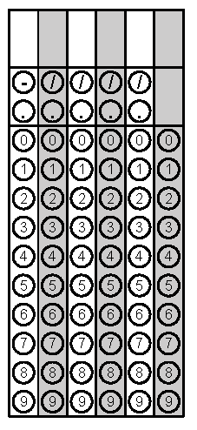
Tuesday | Sanjay is trying to determine if the points  (-2, 4), (-3, 10), (-1, 12), and  (-4, 6) represent a function. Explain how you know these points represent a function.  Yes, each x-value has only one corresponding y-value. | What is the rate of change in the table below?  X Y  1 5  3 9  5 13  7 17  11 25  2 | Problem 2
Wednesday | Harper is filling her little sisters wading pool full of water. Sketch a graph and write a description of this situation.  Answers will vary. Students should show the water level increasing at constant rates unless they include reasons in the story were changes would be occurring. | Find the volume of a cone with a radius of 5.5 inches and a height of 10.4 inches to the nearest tenth.  329.3 in³ | Problem 2
Thursday | Amy is trying to decide what vehicle to purchase based on the best gas mileage.  - The Drive 450 has a gas mileage of y = 23x, where x is the number of gallons of gas used for y miles driven.  - The Zoom 560 has a gas mileage displayed in the table below.  Gallons of Gas Miles Driven  3 75  4 100  6 150  10 250  Which car should Amy buy based on the gas mileage? Explain. The Zoom 560 has a better gas mileage with 25 MPG versus the Drive 450 which has 23 MPG | Approximate the value of $-\sqrt{52}$to the nearest tenths place.  -7.2 | Problem 2
Friday | A rectangle’s length is 4 inches less than three times the width. The perimeter of the rectangle is 32 inches. Find the dimensions of the rectangle.  5 inches by 11 inches | Solve for x:  $$\frac{3^{x}}{3^{8}}=\frac{1}{3^{5}}$$  x = 3 | Problem 2

