 | Problem 1 | Problem 2 | Gridded Response
Monday | Simplify  $$\sqrt{81}∙0.\overline{17}$$ | If a relation includes the points {(-4, 10), (2, -3), (2, -5), (-1, 4), (4, -3)}, which point could be removed to allow the relation to represent a function? | Problem 1  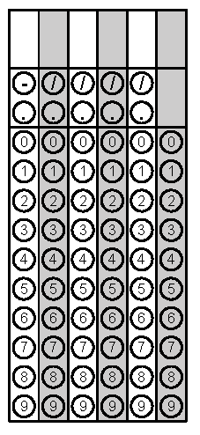
Tuesday | If the sum of the base angles of an isosceles triangle is equal to twice the measure of the third angle reduced by 20. Find the measure of the congruent angles. | What is the slope of the line that goes through the points in the table below?  x y  -5 -5  0 -3  5 -1  10 1 | Problem 2
Wednesday | Find the slope of the line that goes through the points (-5, 7) and (10, 4) | Explain why a vertical line would not represent a function. | Problem 1
Thursday | Does the table below represent a function?  x y  2 1  5 6  8 4  10 3  9 3  8 3 | Jessie is deciding what to purchase at Chick For You. She can buy 5 sandwiches and have $3 in change or she can buy 2 sandwiches and have $9 in change. Find the cost of each sandwich. | Problem 2
Friday | Jason is trying to decide which type of candle to purchase for his Grandfather’s birthday cake. He wants to find the slowest burning candle because he wants his Grandfather to enjoy the moment of blowing out his 90 candles! He finds that Long Last Candles burn at a rate of 3 cm per minute and Burn Slow Candles burn at a rate of y = -3.2x + 20 cm per minute. Which candle should he purchase for his Grandfather’s cake? | Simplify  $$\frac{3^{5}∙2^{0}∙3^{-1}}{3^{7}∙2^{4}∙2^{-5}}$$ | Problem 2

