 | Problem 1 | Problem 2 | Gridded Response
Monday | Simplify  $$\sqrt{81}∙0.\overline{17}$$  17/11 | If a relation includes the points {(-4, 10), (2, -3), (2, -5), (-1, 4), (4, -3)}, which point could be removed to allow the relation to represent a function?  (2, -3) or (2, -5) | Problem 1  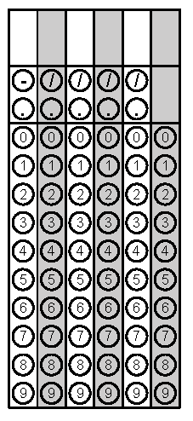
Tuesday | If the base angles of an isosceles triangle are each twice the measure of the third angle reduced by 10. Find the measure of the congruent angles.  70 degrees | What is the slope of the line that goes through the points in the table below? 2/5  x y  -5 -5  0 -3  5 -1  10 1 | Problem 2
Wednesday | Find the slope of the line that goes through the points (-5, 7) and (10, 4)  -1/5 | Explain why a vertical line would not represent a function.  A vertical line would not pass the vertical line test because it would have more than one y-value for the given x-value. | Problem 1
Thursday | Does the table below represent a function?  x y  2 1  5 6  8 4  10 3  9 3  8 3  No, the x-value of 8 corresponds to more than one y-value. | Jessie is deciding what to purchase at Chick For You. She can buy 5 sandwiches and have $3 in change or she can buy 2 sandwiches and have $9 in change. Find the cost of each sandwich.  $2 | Problem 2
Friday | Jason is trying to decide which type of candle to purchase for his Grandfather’s birthday cake. He wants to find the slowest burning candle because he wants his Grandfather to enjoy the moment of blowing out his 90 candles! He finds that Long Last Candles burn at a rate of 3 cm per minute and Burn Slow Candles burn at a rate of y = -3.2x + 20 cm per minute. Which candle should he purchase for his Grandfather’s cake? Long Last Candle burns at a slower rate of 3cm per min. versus 3.2 cm per min for Burn Slow. | Simplify  $$\frac{3^{5}∙2^{0}∙3^{-1}}{3^{7}∙2^{4}∙2^{-5}}$$  2/27 | Problem 2

