 | Problem 1 | Problem 2 | Gridded Response
Monday | Describe the graph below as increasing or decreasing, linear or non-linear from  x = -2 to x = 2. Decreasing and nonlinear.  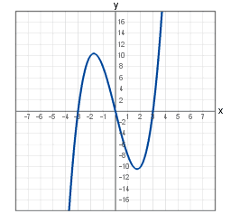 | On a coordinate plane, find the distance between the points (-2, -2) and (4, 6) using the Pythagorean Theorem.  10 units | Problem 2  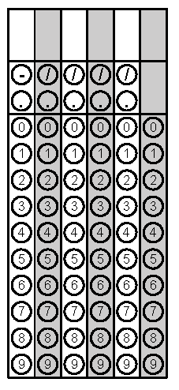
Tuesday | If the area of a square is $\frac{16}{25}square inches$, find the perimeter of the square?  $\frac{16}{5}$ units | Find the product of the least value and greatest value in the list of numbers below. Write your answer in scientific notation.  2.2 x 10⁻³  2.4 x 10⁻²  3.1 x 10⁻¹  2 x 10⁻³  (2x 10⁻³)(3.1 x 10⁻¹) = (6.2 x 10⁻⁴) | Problem 1
Wednesday | Find the slope of the line that goes through points (-2, 2) and (4, -1).  -1/2 | If the volume of a cylindrical can is 226.09 in² and the height of the can is 8 inches, find the radius of the can.  3 inches | Problem 2
Thursday | Find the difference in slopes of the two lines described below.  Line 1: y = -2x + 1  Line 2: goes through points (0, 5) and (2, 6)  $2\frac{1}{2}$ or $\frac{5}{2}$ | Sketch a graph of the following situation. Susan drives to the local coffee shop. She goes in to order a White Chocolate Mocha. She then drives to work at a faster pace. She has to stop at one stoplight and then continues her drive to work.  Answer will vary. Sketch should show an increasing interval, a horizontal line, increasing interval with steeper slope then first increase, a horizontal line, then a final increasing interval. | Problem 1
Friday | Solve for x:  $$\sqrt[3]{x}-9=-1$$  x = 512 | Write an equation in slope intercept form of a line that passes through the points (-5, 3) and (5, 7).  y = 2/5x + 5 | Problem 1

