 | Problem 1 | Problem 2 | Gridded Response
Monday | If a 10-foot ladder reach 8 feet up a building, how far is the base of the ladder from the building? | Draw an example of a graph that is nonlinear and increasing. | Problem 1  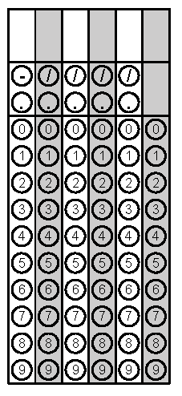
Tuesday | Find the equation of the line that passes through the points (-2, 4) and (3, -11). | What is the value of the expression  $$\frac{81,000,000}{2.7×{10}^{4}}$$ | Problem 2
Wednesday | Find the two solutions of the equation $x^{2}+7=43?$ For the grid-in response, grid only the positive solution. | Circle the rational values.  $$0.343453456…$$  $$0.\overline{23}$$  $$\sqrt{49}$$  $$\frac{6π}{2π}$$ | Problem 1
Thursday | Two angles of a triangle measure 36$°$ and 57$°$, find the measure of the third angle. | Solve for x.  $$5x+3\left(3x-2\right)=2\left(7x-3\right)$$ | Problem 1
Friday | What is the slope of the line that passes through the points (-4, 2) and (-4, -3)? | Pranav sends 25 text messages per minute. The rate Zania sends texts is shown in the table below. What is the difference in their texting rates?  Minutes # of texts  2 48  5 120  6 144 | Problem 2

