 | Problem 1 | Problem 2 | Gridded Response
Monday | If a 10-foot ladder reach 8 feet up a building, how far is the base of the ladder from the building?  6 feet | Draw an example of a graph that is nonlinear and increasing.  Example: | Problem 1  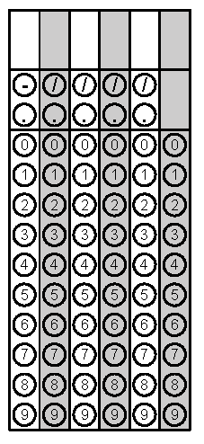
Tuesday | Find the equation of the line that passes through the points (-2, 4) and (3, -11).  y = -3x - 2 | What is the value of the expression  $$\frac{81,000,000}{2.7×{10}^{4}}$$  3000 | Problem 2
Wednesday | Find the two solutions of the equation $x^{2}+7=43?$ For the grid-in response, grid only the positive solution.  6 and -6 | Circle the rational values.  $$0.343453456…$$  $$0.\overline{23}$$  $$\sqrt{49}$$  $$\frac{6π}{2π}$$ | Problem 1
Thursday | Two angles of a triangle measure 36$°$ and 57$°$, find the measure of the third angle.  87$°$ | Solve for x.  $$5x+3\left(3x-2\right)=2\left(7x-3\right)$$  Infinite Solutions | Problem 1
Friday | What is the slope of the line that passes through the points (-4, 2) and (-4, -3)?  Undefined slope | Pranav sends 25 text messages per minute. The rate Zania sends texts is shown in the table below. What is the difference in their texting rates?  Minutes # of texts  2 48  5 120  6 144  Pranav sends 1 more text per minute than Zania | Problem 2

