 | Problem 1 | Problem 2 | Gridded Response
Monday | Explain why the table below does not show a function.  X Y  -2 5  3 15  4 17  9 -23  3 28  The x-value of 3 corresponds to more than one y-value. | Triangle ABC is an isosceles triangle. The congruent sides have a measure of 3x – 4 and the base has a measure of x. If the perimeter of the triangle is 41 centimeters. Find the length of the congruent sides.  17 centimeters | Problem 2  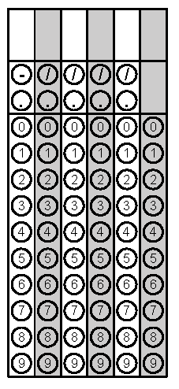
Tuesday | If the equation y = -3x + 4 were shifted down 4 units, what would be the new y-intercept of the line?  0 | Identify whether the table below is linear or non-linear.  X Y  1 5  2 9  4 17  6 25  Linear, constant rate of change | Problem 1
Wednesday | If Deza has 3 straws measuring 13 feet, 17 feet, and 25 feet, could she use the straws to make a right triangle?  No, 13² + 17² does not equal 25² | Evaluate  $$\frac{{(2^{3})}^{5}}{2^{17}}$$  $$\frac{1}{4}$$ | Problem 2
Thursday | Christina dogsits in her neighborhood and charges 15 plus 4 per hour of playing with the dogs. Write an equation that can be used to determine e, Christina’s earnings for dogsitting h hours.  e = 4h + 15 | If Line AB is parallel to line CD and the measure of angle 2 is 5x and the measure of angle 7 is 3x + 8, find the degree measure of angle 2.  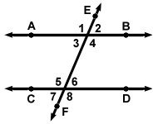  20$°$ | Problem 2
Friday | What is the slope of the line that passes through the points (-2, 7) and (3, -2)?  $$-\frac{9}{5}$$ | Triangle ABC and DEF have the same interior angle measures. Are the triangles similar? Explain.  Yes, if all the interior angles of two triangles are congruent then the sides will be proportional, thus similar figures. The Angle-Angle Similarity Postulate. | Problem 1

